Name: _________________

Date: __________________

**Warm Up 1.2 SHOW YOUR WORK!!!**

Solve the following problems by hand, use a graphing calculator to check:

1. Determine if the Relation is a Function, explain why or why not.

a. b.

c. 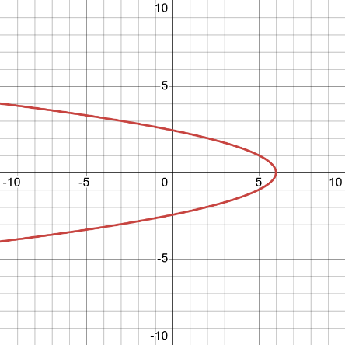

2. Let’s get ready for today!

a. Simplify: ${\left(y+3\right)}^{2}$ b. Evaluate: $x^{2}-3x+10$ for $x=-2$

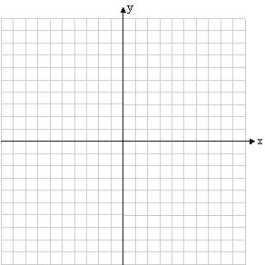c. Graph $y=-2x+5$ in your graphing calculator. Look at the table and plot at least 3 points and the line below.